Monkeypox Disease Classification using HOG-SVM Model

Janhavi Kulkarni1 and Poorvi Verma1 and Snehal V. Laddha*2

1 Department of Electronics Engineering, Shri. Ramdeobaba College of Engineering and Management, Nagpur, Maharashtra, 440013, India

1[kulkarnijs@rknec.edu](mailto:kulkarnijs@rknec.edu)

1[vermapb@rknec.edu](mailto:vermapb@rknec.edu)

2[laddhasv2@rknec.edu](mailto:laddhasv2@rknec.edu)

**Abstract.** Monkeypox is a viral disease that has caused outbreaks in different parts of the world through human-to-human transmission. The increasing number of cases of Monkeypox in recent years highlights the need for timely detection to prevent further spread and ensure prompt treatment. In our research paper, we have employed the latest technology of AI through Machine Learning models for the detection of Monkeypox. Our aim is to reduce computational time and enhance accuracy by identifying images as either Monkeypox or non-Monkeypox. We reviewed various research studies in this field and found that most of them are based on Deep Learning, which makes them computationally complex. After training and testing our model using available datasets, we evaluated its performance using parameters such as accuracy, precision, F1 score, and recall for each extraction technique. Our experiments yielded an accuracy of 0.94, an F1 score of 0.95, a precision of 0.93, and a recall of 0.97. Our newly developed model will be highly beneficial in the medical field, particularly for countries with large populations such as China, India, and the United States, for the detection of Monkeypox on a mass scale.

**Keywords:** Monkeypox, Machine Learning, Deep Learning, accuracy, F1 score, Recall

1. Introduction

The global spread of the monkeypox epidemic in May 2022 has greatly alarmed the population, especially in light of the still-evolving Coronavirus Disease 2019 (COVID-19) pandemic[1].Monkeypox is a disease which is considered to be similar to small pox but is clinically severe. It is a zoonotic disease. There is considered to have discovered two different clades of monkey virus namely western and Central Africa (Congo basin) [2].Monkeypox disease is caused by the MPXV, a close relative of the variola virus, and is similar to smallpox but less severe[3].The variola virus, which causes smallpox, the vaccinia virus, and the cowpox virus are also members of this virus. The first documented human case occurred in 1970 in a 9-month-old boy in the DR Congo[4]. Since that time, monkeypox has become endemic in the DRC, and has spread to other African countries, mainly in Central and West Africa. Outside of Africa, the first reported monkeypox cases were in 2003 and, at the time of this systematic review, the most recent cases were in 2019[5].

* 1. Transmission

The spread of the virus was observed to have been caused due to import and export of exotic animals from African regions or the regions where the virus is endemic[6]. They were first discovered in African monkeys. Among the two clades existing, clad Central African is considered to have eligible for human-to-human transmission unlike the Western African clade[6]. Additionally, contaminated items and materials like pillows, bedding, and the like can spread the virus. The main mode of transmission for this most recent outbreak of the virus has been identified as sexual contact[7].

* 1. Symptoms of Monkeypox Disease

The duration between emerging into contact with a patient who was exhibiting symptoms of monkeypox and the appearance of a rash was known as the incubation period. Because families could remember the day of rash onset better than the day of fever onset, rash was chosen as the benchmark of infection for estimating incubation periods[3]. Initially, the patient experiences headache, muscle ache, and backache with frequent sweat, fatigue and a most crucial symptom which disseminates smallpox from monkeypox is lymphadenopathy. Lesions begin in the oropharynx and then make a presence in the skin [6]. Other painful symptoms also include turgidity in skin lesions and lymph nodes. The incubation period ranges from approximately 7-14 days[2].

* 1. Traditional detection

The hemagglutination test is a straightforward and cost-effective method for detecting viruses. The hemagglutination inhibition (HI) assay was created as a result of the hemagglutination mechanism. The HI method uses antibodies that are specific to the virus to find viral antigens[8]. Also, Nucleic acid amplification testing (NAAT), which looks for specific viral DNA sequences using real-time or conventional polymerase chain reactions (PCR), is used to confirm MPXV infection. Sequencing can be done alone or in conjunction with PCR. In other procedures, the initial PCR reaction detects OPXV but does not specify which species it belongs to. A second step can then be taken to precisely detect MPXV, which may be PCR-based or involve sequencing[9].

Whole particle detection using electron microscopy method provides great resolution of electron microscopy (EM) enables research at the nanoscale scale and provides clear images of viruses for analysis and diagnosis. For several reasons, transmission electron microscopy (TEM) is an excellent first step in the diagnosis of viruses. But EM is considered a costly treatment[10].

Below Figure 1 shows traditional methods of detection of disease in accordance with their year of origin.

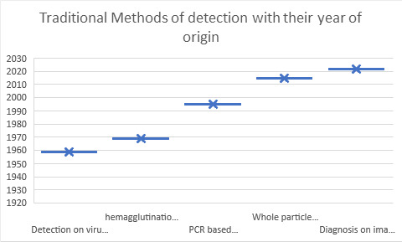

Fig. 1. Direct Detection analysis

* 1. Traditional Treatments of Monkeypox

Infection went out of Africa in rare cases, however there were cases reported in Singapore, Israel, UK and even at times US in 2021. On this day, there is no specified treatment for monkeypox. But the two orally bioavailable drugs- Brin cidofovir and tecovirimat were agreed to prescribe in US to eradicate smallpox. These two drugs presented strong potency against ortho pox viruses which includes monkeypox usually accepted for animal models[11]. In most critically severe cases, dual therapy (both drugs) is used. The potency of tecovirimat drug is vague but has been proved effective over placebos. Brin cidofovir has been authorized for the treatment of smallpox in the US. Despite the lack of clinical studies on cidofovir's effectiveness against monkeypox in people, it has been found to be effective in vitro against deadly monkeypox virus infections in animals[12].

* 1. AI-based detection

Human resources are a rising problem in the world considering recent times. The need for adept doctors and skilled diagnoses is on the surge. The process of diagnosis can turn tiresome and can be full of anomalies. Therefore, there arises a need for a system of diagnosis which is quick, gives accurate results. For the diagnosis process to yield accurate results at a lower cost, a suitable decision support system is required[13]. Artificial intelligence (AI) technologies have been increasingly included into clinical diagnostic systems over the past three decades to increase their accuracy. By automating and standardizing the interpretation and inference processes as well as increasing the diagnostic accuracy, AI-based solutions can aid in decision-making. It is crucial to remember that the quality and effectiveness of AI technologies can be directly affected by the type of raw data used[14].

As the world population is on a surge, there is a need for advancement in the medical field for the diagnosis and treatment of diseases. With the emergence of artificial intelligence and Machine Learning technology, different ML/DL models in various domains in the field of research have been proposed, and the detection of diseases in humans such as brain cancer, tumour, lung cancer, Covid, Monkeypox etc[15]. In machine learning, different models are based on HOG (Histogram of orient gradient), LBP (linear binary pattern), SIFT, and many other algorithms for feature extraction and random forest, SVM (Support Vector Machine), KNN (K-nearest neighbour) etc for classification. These models are pre-trained based on the large datasets provided and then testing is done. The dataset can be in the form of MRI images, X-Ray Images, greyscale images, RGB images. In this research paper, we have taken HOG for the feature extraction whereas for classification we have taken SVM. The dataset we have taken is the png format of RGB images for humans having monkeypox and non- monkeypox.

With discoveries in the area of artificial intelligence (AI) and ever-increasing technological development, novel ML and DL techniques can analyse medical data more efficiently. Benefitted from this overall growth, researchers are building better ML and DL models to deal with even more complex and abundant medical data[16].Outside of medicine, machine learning is now used broadly, playing a critical part in important activities. Recent developments in machine learning have enabled some of these jobs that were previously impossible. Modern machine learning techniques are quite resilient to real-world challenges, and the systems gain from the forced removal of certain input throughout the learning process[17].

1. Literature Survey

In this study, we have tried to increase the accuracy of image detection in our model using machine learning. In this study, we have tried to increase the accuracy of image detection in our model using machine learning.

In one of the previously published papers by Sitaula and Shahi 2022 [15], the accuracy of 87.13%, precision of 85.14%, F1 score of 85.4%, and recall of 85.7% from Deep learning models were achieved. Researchers are using Transfer learning as well as the monkeypox dataset and are using 13 pre-trained DL models for detection as well as comparison. They have shown the explainability of the model using Gradient Weighted Class Activation Mapping and Local Interpretable Model-Agnostic Explanations techniques of visualization. The best-performing model in this excellent paper is the Xception model although the Ensemble approach is proved to be the best of all [15].

Ali et al. 2022[18],assessed the effectiveness of the chosen, pre-trained models for the experiment in the threefold merge. Though ResNet50 produces the highest accuracy (82.96%), VGG16 performs fairly (81.48%). The Ensemble approach of paper performs less than the above two.

Sahin et al. 2022[19], describes a portable device that can automatically find skin lesions caused by human monkeypox. To do this, first, photos from the MSLD database were used to train a deep transfer learning-based system. Subsequently, MobileNetv2, which demonstrated one of the best accuracy results (91.11%), precision(90%), F1 score(90%), sensitivity(90%)  was converted into an Android mobile application.

Pramanik et al. 2023[20], suggested a methodology based on ensemble learning to identify the monkeypox virus. For optimal performance on a target Monkeypox dataset, they first take into account three pre-trained base learners, namely Inception V3, Xception, and DenseNet169. A five-fold cross-validation configuration is used to thoroughly test the framework on a publicly accessible dataset of monkeypox skin lesions. The model achieves average accuracy, precision, recall, and F1 scores of 93.39%, 88.91%, 96.78%, and 92.35%, respectively.

Aldera and Othman [21], introduces a model that uses a picture of the diseased skin to identify psoriasis, cherry angioma, melanoma, and acne. The suggested model is made of Image acquisition, preprocessing, segmentation, feature extraction, and classification are the five steps. In addition to employing Support Vector Machine (SVM), Random Forest (RF), and K Nearest Neighbour (K-NN) classifiers as machine learning techniques to evaluate the model. The SVM classifier with accuracy of 90.8% is the best.

Ru et al. 2023[22]. This paper aims to have a comparison between extreme gradient boosting XGBoost and logistic regression to have a prediction of which US counties are most likely to have measles. The best performing model of this paper is XGBoost and XGBoost hybrid models and is able to provide more accurate predictions than other models considered. But, Logistic regression or logistic regression hybrid models has been seen to have provides with higher sensitivity that is recall values than XGBoost or XGBoost hybrid models.

Table 1. represents a comparative analysis of various DL-based models used by various researchers for Monkeypox disease detection and classification.

|  |  |  |  |
| --- | --- | --- | --- |
| Table 1. A comparative analysis of various DL-based models for Monkeypox disease detection and classification. | | | |
| **References** | **Proposed method** | **Models** | **Parameters** |
| Sitaula and Shahi 2022[15] | Monkeypox Virus Detection Using Pre‐trained Deep Learning | Ensemble-13 different DL models | Accuracy:87.13%  Precision:85.44%  F1 score:85.40%  Recall:85.47% |
| Ali et al. 2022 [18] | Monkeypox Skin Lesion Detection Using Deep Learning Models. | ResNet50 | Accuracy:82%  Precision:87%  F1 score: 84%  Recall:83% |
| Sahin et al. 2022 [19] | Human Monkeypox Classification from Skin Lesion Images with Deep Pre-trained Network | MobileNetv2 | Accuracy:91.11%  Precision:90%  F1 score: 90%  Sensitivity: 90% |
| Pramanik et al. 2023 [20] | Monkeypox detection from skin lesion images using an amalgamation of CNN models | Hybrid CNN Model | Accuracy:91.21%  Precision:88.91%  F1 Score: 92.35%  Recall: 96.78% |
| Aldera and Othman 2022[21] | A Model for Classification and Diagnosis of Skin Disease using Machine Learning | Gabor and Entropy techniques | Accuracy:90.7%  Precision:91.00%  F1 Score: 90.8%  Recall: 90.8% |
| Ru et al.2023[22] | Predicting Measles Outbreaks in the United States: Evaluation of Machine Learning Approaches | XGBoost hybrid Linear regression | Sensitivity: 85.9%  Specificity: 95% |

1. Materials and Methods

#### In this paper, the materials we have used the images of skin lesions as the dataset and particular methods have been applied to get the end results. At the end of the images are classified as monkeypox and non-monkeypox and the concerned parameters are calculated. Below Figure 2 shows the block diagram we have followed for our experimentation models.

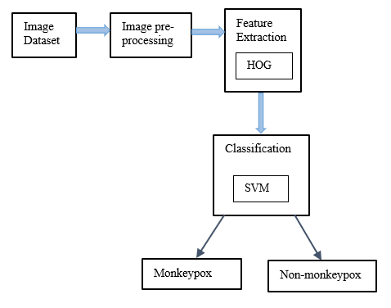

**Fig. 2.**Block diagram of the experimentation models

* 1. Dataset

In our research paper, we are using an image dataset. It has both augmented and original images suitable for DL and ML models. The dataset includes images for binary classification of monkeypox and non-monkeypox. The dataset procured was in the form of jpg images. For this study, we have converted it into lossless PNG images[15].The images shown below represent the original monkeypox image, it’s resized image and the HOG image of the resized image.

Figure 3 shows sample images of dataset used for the model.

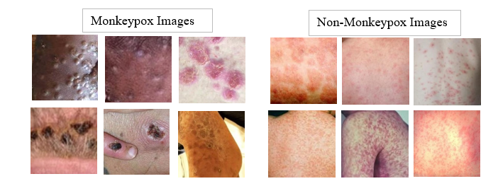

**Fig. 3**. Sample images from the dataset

The dataset we have collected from the website for the training and testing of our ML based model consist of png human skin images affected with Monkeypox disease and other infected disease such as smallpox, chickenpox etc. which appear similar to monkeypox. The dataset is categorized into two parts, the first part comprises of 517 monkeypox affected images and the other part having 636 non-monkeypox images. In the below figures, Figure 4 shows the Original Image, Figure 5 shows a resized image whereas Figure 6 shows the HOG image.

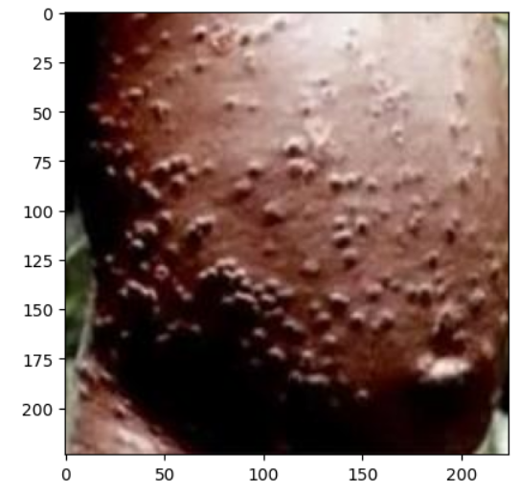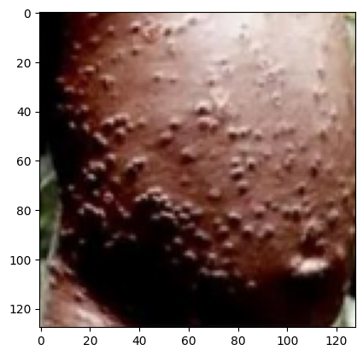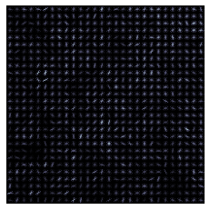

**Fig 4.** Original Image **Fig 5.** Resized Image **Fig 6.** HOG image

(224x224) (128x128) (128x128)

* 1. Feature Extraction

The process of feature extraction converts unprocessed data into numerical characteristics that may be used by machine learning algorithms. Different feature extraction methods are Gray-Level Co-occurrence Matrix (GLCM), Gray-Level Run Length Matrix (GLRLM), Scale-Invariant Feature Transform (SIFT), Histogram of Oriented Gradients (HOG), Local Binary Pattern (LBP) etc. The method we used in this paper is Histogram of Oriented Gradients (HOG).

**HOG**: Compared to other characteristics already on the market, the histogram of Oriented Gradient (HOG) performs exceptionally well. The fundamental premise is that local object appearance and shape may frequently be accurately predicted by the distribution of local intensity gradients or edge orientations, even when the precise gradient or edge positions are unknown. The purpose of HOG is to provide a local-oriented gradient histogram description of an image. These histograms depict instances of a certain gradient orientation in smaller regions of the image[23]. The HOG feature extraction approach can be broadly broken down into the following steps: The image must first be adjusted in order to lessen the impact of lightning. The noise of the image is then eliminated using a discrete Gaussian smoothing template, and the gradient of the image is determined. The orientation histogram is built in each cell unit as the next step. These cell units are then synthesized into substantial regions, and their HOG characteristics are gathered[24]. The HOG feature extraction approach has the following benefits: The gradient distribution and edge direction can be used to describe the discovered image. Moreover, this approach may effectively capture local shape information and maintain strong stability for changes in both geometry and optics. Moreover, this method increases feature extraction rates without sacrificing feature information[24]. Below figure 7 shows flowchart for feature extraction using Histogram of Oriented Gradients.

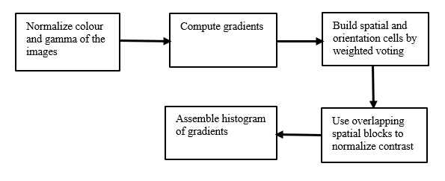

**Fig. 7.** Flow chart for Feature Extraction using HOG.

* 1. Classification

In the case of monkeypox disease, image classification could potentially be used to identify and classify different stages of the rash associated with the disease, also to classify images with or without monkeypox disease. This could help with early detection and diagnosis of the disease, which is important for effective treatment and control. However, it is important to note that image classification for medical diagnosis purposes would require rigorous testing and validation before it could be used in clinical practice. For our experimentations we have selected most commonly used machine learning based classifier i.e., Support Vector Machine (SVM).

* 1. Support Vector Machine (SVM)

Support Vector Machine is a crucial machine learning (ML) technique that offers several benefits in the resolution of the limited sample, nonlinear, and high latitude pattern recognition issues. A promising method based on statistical learning theory and pattern recognition is the support vector machine. SVM is initially only an unfinished mathematical theory. The researchers are next suggest reconstructing SVM with a restriction on linear inequality, which resolves the issue of linear inseparability. Following this, the SVM theory is successfully utilized in various fields thanks to further research and ongoing optimization by professionals [24]. The hyperplane, a decision boundary, is oriented to be as far away from each class's nearest data point as is physically possible. Support vectors are used to describe these nearest places[25]. Binary SVM classifiers are used to distinguish data points of two categories. An n-dimensional vector is used to represent each data object (or data point). These data items can only be classified into one of two categories[26]. They are divided using a linear classifier using a hyperplane. The biggest margin hyperplane is selected by SVM to maximize separation between the two classes. The margin is calculated as the sum of the shortest distances between the closest points of both categories' data and the separating hyperplane[26].

1. Implementation

In this paper, we opted for a machine learning approach, specifically the HOG-SVM model, for monkeypox disease classification due to its suitability for smaller datasets and faster processing times compared to deep learning models. The HOG feature descriptor eliminates the need for extensive preprocessing, while the model provides interpretable results, aiding in understanding the disease characteristics. We collected the dataset which was in the form of images from the public website Kaggle. The images of the size 224x224 were taken as input which was resized. We extracted the features of the resized images using Pre-trained HOG and LBP models. As the purpose of the HOG is to histogramatically characterize a picture using a series of locally directed gradients and these histograms show instances of a certain gradient orientation in a small area of a picture, HOG is typically used to identify a certain object in images and that is the reason HOG performs well for human detection. HOG uses the angle of gradient and magnitude, to compute the features, making it effective for feature extraction. In the later part after image processing, classification was done using SVM classification. The main idea behind selecting SVM is that binary classification as the algorithm produce very accurate classifiers and has less overfitting along with it is robust to noise.

The experimentations were carried out in a Python programming environment with libraries offered by Google Colab. Different libraries for implementing Machine Learning algorithms were used such as Skimage library was used for HOG feature extraction. Later after implementing the training and testing models, we have evaluated the performance parameters namely F1 score, precision, accuracy, and Heat Map of the model.

1. Evaluation Matrices

We have evaluated our performance based on Accuracy(A), Precision (P), Recall(R) and F1 score (F1). The 4*4 grid in the heat map denotes True Positive (TP), False Positive (FP), True Negative (TN), and False Negative (FN). The formulae for calculating Precision, Recall, and F1 score are as follows: -

$A = (TP+TN)/(TP+TN+FP+FN)$--------(1)

$P = TP/ (TP + FP)$ -------------------------------(2)

$R = TP/ (TP + FN)$-------------------------------(3)

$F1 = 2 × (P × R)/ (P + R)$ -------------------(4)

1. Result

In this research paper, we have considered a pre-trained feature extraction method and applied the classification to the images after extracting their characteristic features. Various performance parameters were calculated using the above formulae and evaluated on the basis of the results for the HOG-SVM model. In figure 8, we generated the heat map of the evaluation. The heat map is a 2x2 matrix that shows the values of True positive, true negative, false positive and false negative for the dataset provided.

**Table II:** The performance parameter metrics

|  |  |  |  |  |
| --- | --- | --- | --- | --- |
| Methodology | Accuracy | F1 score | Precision | Recall |
| HOG +SVM | 0.94 | 0.95 | 0.93 | 0.97 |

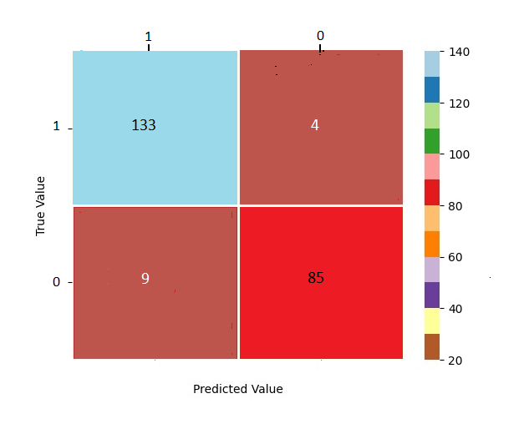

**Fig. 8.** Heat Map of HOG-SVM performance model

1. Conclusion

In this research study, we have used the machine learning algorithm for monkeypox disease classification on an open-source dataset. Our approach with the HOG-SVM model has proven to be more efficient. The performance evaluation of our model yielded promising results, with an accuracy of 0.94, an F1 score of 0.95, a precision of 0.93, and a recall of 0.97. Machine learning models are more efficient, simpler to interpret and accurate for the smaller dataset whereas the deep learning models are complex with multiple layers including input, convolution, pooling and many other for processing data. The Heat Map generated for testing images, represents the performance of binary classification of the disease in our research.

Further in the future, we will try to collect more datasets and apply hybrid model of machine learning and deep learning for the classification of monkeypox images. The future scope also includes classification and detection of various hazardous diseases which we will be valuable in the field of healthcare and the mankind.

References

1. M.-H. Temsah *et al.*, ‘Monkeypox caused less worry than COVID-19 among the general population during the first month of the WHO Monkeypox alert: Experience from Saudi Arabia’, *Travel Med Infect Dis*, vol. 49, p. 102426, Sep. 2022, doi: 10.1016/j.tmaid.2022.102426.
2. M. Altindis, E. Puca, and L. Shapo, ‘Diagnosis of monkeypox virus – An overview’, *Travel Med Infect Dis*, vol. 50, p. 102459, Nov. 2022, doi: 10.1016/j.tmaid.2022.102459.
3. L. D. Nolen *et al.*, ‘Extended Human-to-Human Transmission during a Monkeypox Outbreak in the Democratic Republic of the Congo’, *Emerg Infect Dis*, vol. 22, no. 6, pp. 1014–1021, Jun. 2016, doi: 10.3201/eid2206.150579.
4. A. Yinka-Ogunleye *et al.*, ‘Outbreak of human monkeypox in Nigeria in 2017–18: a clinical and epidemiological report’, *Lancet Infect Dis*, vol. 19, no. 8, pp. 872–879, Aug. 2019, doi: 10.1016/S1473-3099(19)30294-4.
5. E. M. Bunge *et al.*, ‘The changing epidemiology of human monkeypox—A potential threat? A systematic review’, *PLoS Negl Trop Dis*, vol. 16, no. 2, p. e0010141, Feb. 2022, doi: 10.1371/journal.pntd.0010141.
6. M. J. Moore, B. Rathish, and F. Zahra, *Mpox (Monkeypox)*. 2022.
7. I. Banerjee, J. Robinson, and B. Sathian, ‘Global re-emergence of human monkeypox: Population on high alert’, *Nepal J Epidemiol*, vol. 12, no. 2, pp. 1179–1181, Jun. 2022, doi: 10.3126/nje.v12i2.45974.
8. I. Gul *et al.*, ‘Current and Perspective Sensing Methods for Monkeypox Virus’, *Bioengineering*, vol. 9, no. 10, p. 571, Oct. 2022, doi: 10.3390/bioengineering9100571.
9. ‘Laboratory testing for the monkeypox virus. May 23,2022.[Online]Available:

<https://apps.who.int/iris/bitstream/handle/10665/354488/WHO-MPX-Laboratory-2022.1-eng.pdf>

1. K. R. Richert-Pöggeler, K. Franzke, K. Hipp, and R. G. Kleespies, ‘Electron Microscopy Methods for Virus Diagnosis and High Resolution Analysis of Viruses’, *Front Microbiol*, vol. 9, Jan. 2019, doi: 10.3389/fmicb.2018.03255.
2. H. Adler *et al.*, ‘Clinical features and management of human monkeypox: a retrospective observational study in the UK’, *Lancet Infect Dis*, vol. 22, no. 8, pp. 1153–1162, Aug. 2022, doi: 10.1016/S1473-3099(22)00228-6.
3. J. G. Rizk, G. Lippi, B. M. Henry, D. N. Forthal, and Y. Rizk, ‘Prevention and Treatment of Monkeypox’, *Drugs*, vol. 82, no. 9, pp. 957–963, Jun. 2022, doi: 10.1007/s40265-022-01742-y.
4. S. Kaur *et al.*, ‘Medical Diagnostic Systems Using Artificial Intelligence (AI) Algorithms: Principles and Perspectives’, *IEEE Access*, vol. 8, pp. 228049–228069, 2020, doi: 10.1109/ACCESS.2020.3042273.
5. R. Alizadehsani *et al.*, ‘Coronary artery disease detection using artificial intelligence techniques: A survey of trends, geographical differences and diagnostic features 1991–2020’, *Comput Biol Med*, vol. 128, p. 104095, Jan. 2021, doi: 10.1016/j.compbiomed.2020.104095.
6. C. Sitaula and T. B. Shahi, ‘Monkeypox Virus Detection Using Pre-trained Deep Learning-based Approaches’, *J Med Syst*, vol. 46, no. 11, p. 78, Oct. 2022, doi: 10.1007/s10916-022-01868-2.
7. A. Garg and V. Mago, ‘Role of machine learning in medical research: A survey’, *Comput Sci Rev*, vol. 40, p. 100370, May 2021, doi: 10.1016/j.cosrev.2021.100370.
8. B. J. Erickson, P. Korfiatis, Z. Akkus, and T. L. Kline, ‘Machine Learning for Medical Imaging’, *RadioGraphics*, vol. 37, no. 2, pp. 505–515, Mar. 2017, doi: 10.1148/rg.2017160130.
9. S. N. Ali *et al.*, ‘Monkeypox Skin Lesion Detection Using Deep Learning Models: A Feasibility Study’, Jul. 2022.
10. V. H. Sahin, I. Oztel, and G. Yolcu Oztel, ‘Human Monkeypox Classification from Skin Lesion Images with Deep Pre-trained Network using Mobile Application’, *J Med Syst*, vol. 46, no. 11, p. 79, Oct. 2022, doi: 10.1007/s10916-022-01863-7.
11. R. Pramanik, B. Banerjee, G. Efimenko, D. Kaplun, and R. Sarkar, ‘Monkeypox detection from skin lesion images using an amalgamation of CNN models aided with Beta function-based normalization scheme’, *PLoS One*, vol. 18, no. 4, p. e0281815, Apr. 2023, doi: 10.1371/journal.pone.0281815.
12. S. A. Aldera, M. Tahar, and B. Othman, ‘A Model for Classification and Diagnosis of Skin Disease using Machine Learning and Image Processing Techniques’. [Online]. Available: www.ijacsa.thesai.org
13. B. Ru, S. Kujawski, N. Lee Afanador, R. Baumgartner, M. Pawaskar, and A. Das, ‘Predicting Measles Outbreaks in the United States: Evaluation of Machine Learning Approaches’, *JMIR Form Res*, vol. 7, p. e42832, Apr. 2023, doi: 10.2196/42832.
14. F. A. I. Achyunda Putra, F. Utaminingrum, and W. F. Mahmudy, ‘HOG Feature Extraction and KNN Classification for Detecting Vehicle in The Highway’, *IJCCS (Indonesian Journal of Computing and Cybernetics Systems)*, vol. 14, no. 3, p. 231, Jul. 2020, doi: 10.22146/ijccs.54050.
15. P. Xu, L. Huang, and Y. Song, ‘An optimal method based on HOG-SVM for fault detection’, *Multimed Tools Appl*, vol. 81, no. 5, pp. 6995–7010, Feb. 2022, doi: 10.1007/s11042-022-12020-0.
16. ‘Applications of Support Vector Machine (SVM) Learning in Cancer Genomics’, *Cancer Genomics Proteomics*, vol. 15, no. 1, Jan. 2018, doi: 10.21873/cgp.20063.
17. H. Yu and S. Kim, ‘SVM tutorial-classification, regression and ranking’, in *Handbook of Natural Computing*, Springer Berlin Heidelberg, 2012, pp. 479–506. doi: 10.1007/978-3-540-92910-9_15.